|  |  |
| --- | --- |
| EGC_Black | Student Name \_\_\_\_\_\_\_\_\_\_\_\_\_\_\_\_\_\_\_\_\_\_\_    **Eastern Goldfields College**  Mathematics Applications U2 2016  Assignment – Calculator Free1 |
|  | Total Marks: 14 marks |

**Time allowed: 15 minutes**

***Answer all of the following questions. Show all working to obtain full marks.***

Question 1 (6 marks)

1. A straight line has equation $y=4-2x$  
   1. the coordinates of the y-intercept. (1 mark)
   2. the slope of the line. (1 mark)
   3. the coordinates of the x-intercept. (1 mark)
2. Draw the line with equation $y= -\frac{1}{2}x+1$ on the axes below. (3 marks)

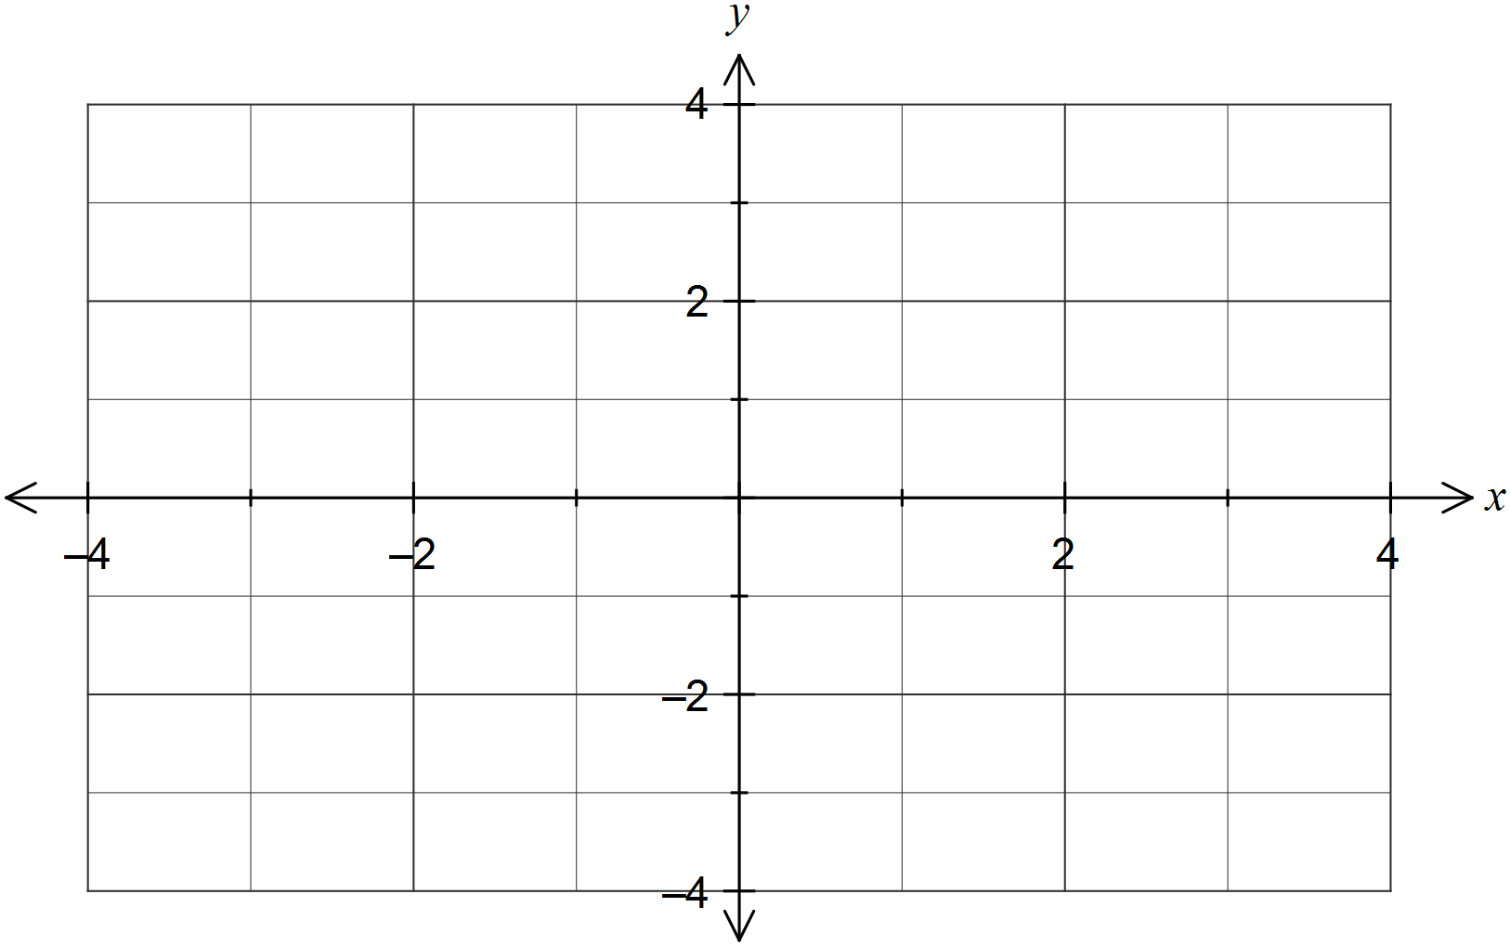

Question 2 (8 marks)

The number of late passes issued daily by a school over a four week period were as follows:

8, 7, 7, 7, 9, 6, 5, 4, 14, 4, 6, 8, 10, 6, 5, 4, 8, 7, 9, 9

(a) Determine the five number summary for this data. (3 marks)

(b) Is the value of 14 in the above list an outlier for the data set? Justify your answer.

(2 marks)

(c) Use the five number summary to construct a box plot on the scale below that reflects your response in (b). (3 marks)

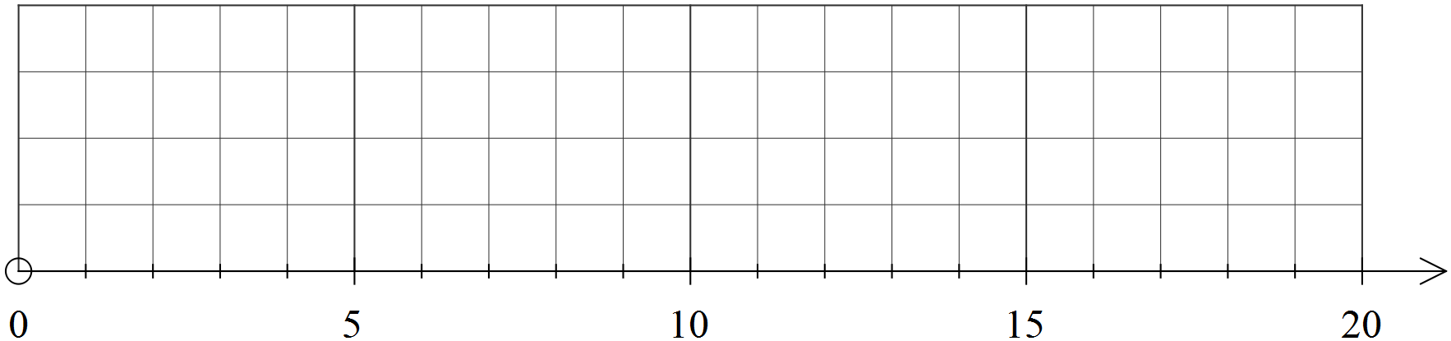

|  |  |
| --- | --- |
| EGC_Black | Student Name \_\_\_\_\_\_\_\_\_\_\_\_\_\_\_\_\_\_\_\_\_\_\_    **Eastern Goldfields College**  Mathematics Applications U2 2016  Test 2 – Calculator Assumed1 |
|  | Total Marks: 18 marks |

**Time allowed: 20 minutes**

**Calculator only, NO notes permitted for this section.**

***Answer all of the following questions. Show all working to obtain full marks.***

Question 3 (10 marks)

The weights of boys and girls who take part in a gymnastics program are summarised in the table below.

|  |  |  |  |  |  |  |
| --- | --- | --- | --- | --- | --- | --- |
| Weight (Kg) |  |  |  |  |  |  |
| Boys | 16 | 116 | 186 | 152 | 68 | 15 |
| Girls | 10 | 80 | 47 | 45 | 20 | 6 |

(a) Are weights an example of categorical, continuous or discrete data? Justify your answer.

(2 marks)

The mean and standard deviation of the boy's weights is 43.3 and 11.1 kg respectively.

(b) Calculate the mean and standard deviation of the girl's weights. (2 marks)

The graph below shows the weight distribution of the boys.

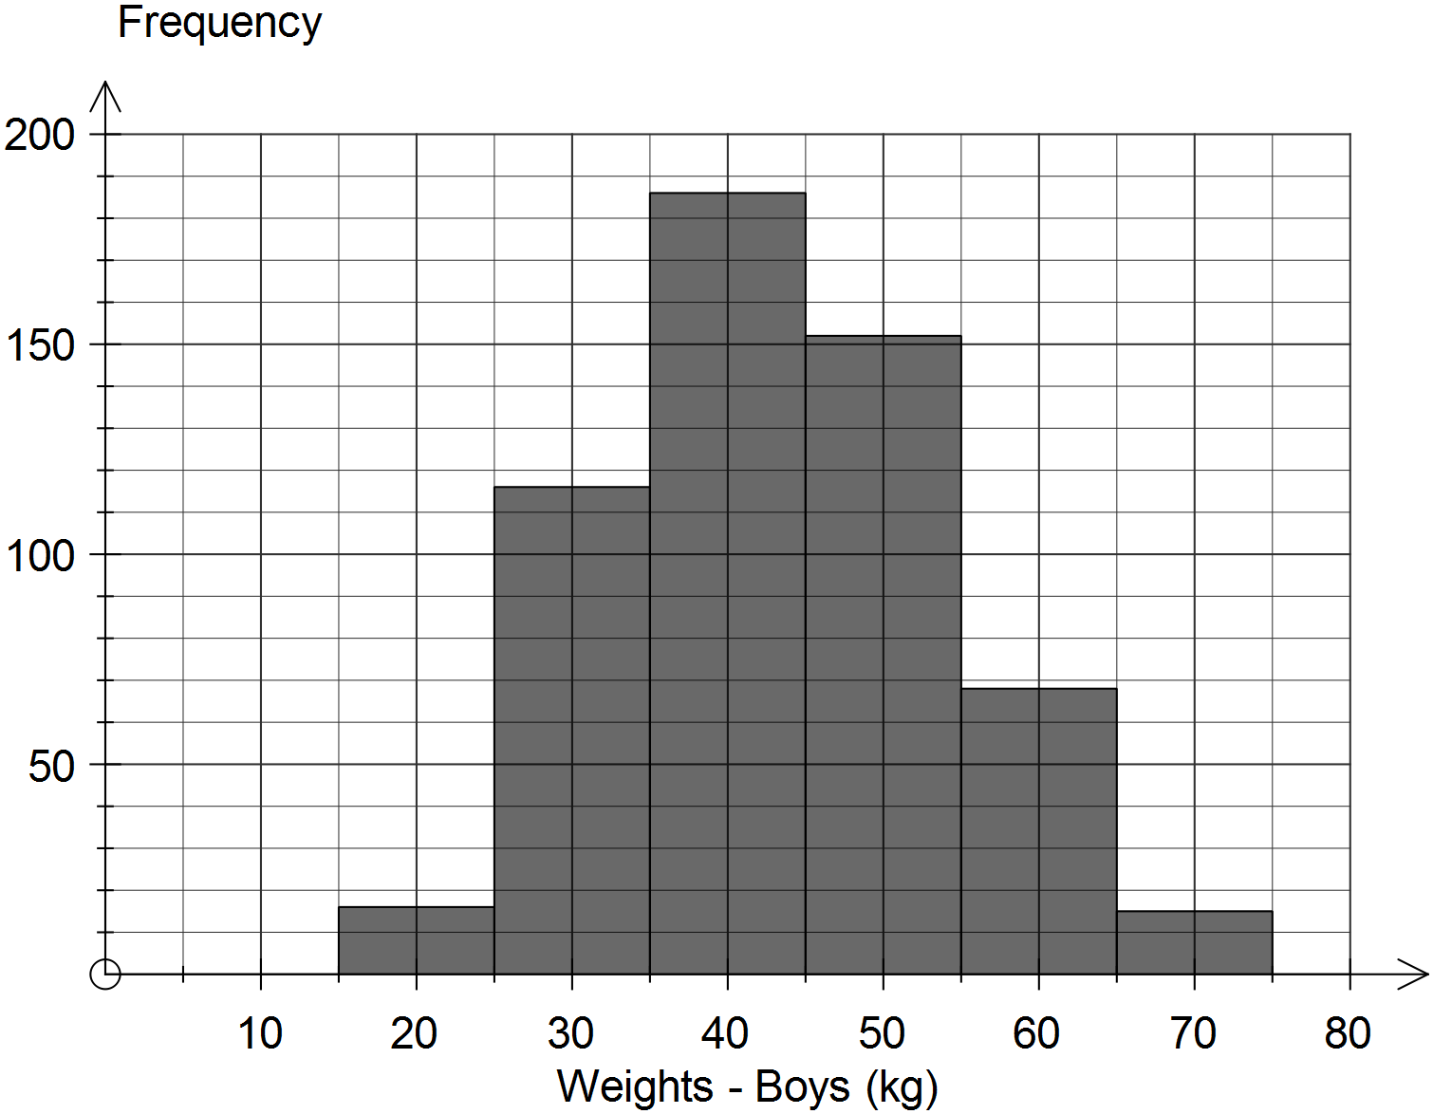

(c) Describe the modality of the distribution of the weights of boys. (1 mark)

(d) Complete the histogram below to show the weight distribution of the girls.

(2 marks)

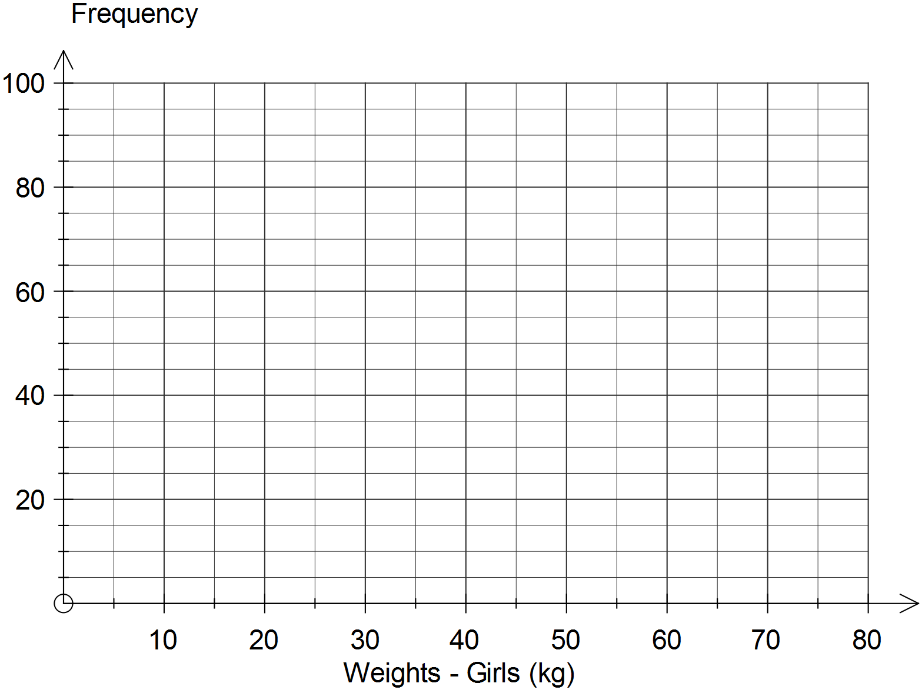

(e) Use the information in this question to comment on any similarities or differences between the weights of boys and girls who take part in the gymnastics program. (3 marks)

Question 4 (8 marks)

(a) A small plane is 22.5 km due south and 15.5 km due east of an airport.

1. Draw a diagram to represent where the plane is located in relation to the airport.

(1 mark)

(ii) Determine the true bearing of the plane from the airport. (2 marks)

1. The town of Woop Woop is 22 km from the town of Porpoise Spit, on a true bearing of 340O. The town of Baccabirk is 48 km from Porpoise Spit, on a true bearing of 070O.
2. Complete the diagram below to represent the locations of these towns from each other.

(1 mark)

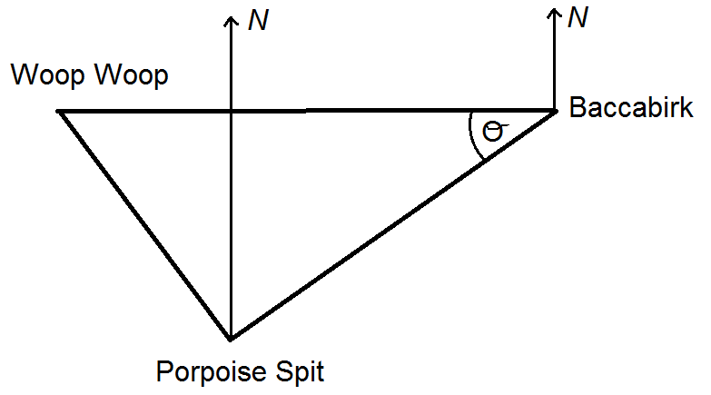

1. Find angle $θ$. Round the nearest degree. (2 marks)

1. Find the true bearing of Woop Woop from Baccabirk. Round to the nearest degree.

(2 marks)